# **Executive Summary**

Banco Popular de Ecuador has been one of the best banks in Ecuador for several years, but foreign banks have started invading the Ecuadorean market. Now the bank wants to improve its processes in order to improve its competitive edge. Our team has been assigned the loan-application process to analyze and improve.

Currently, Type 3 (personal) loans take eleven work days on average to be processed, while corporate loans only take two to three work days. This is a problem because potential Type 3 loan applicants will go elsewhere if the queue ahead of them is too long, not to mention the average time it takes to process a loan application that is submitted is not very competitive. We made it our goal to bring this Type 3 loan processing time below the 2-work-week mark.

At first look, the issue appears to lie with personal loan account executives, risk analysts, and the executive credit approval committee. We decided to test different combinations of numbers of employees using the ExtendSim Scenario Manager, as well as changing the loan priority for committee review from “Type 1 before Type 2” to “First In, First Out”.

The Scenario Manager suggested we add a corporate loan account executive,add a risk analyst, and remove a treasury officer. The results of the optimized model were a shorter cycle time for Type 3 loans but a longer cycle time for Type 1 loans; all loan types fell below the 2-work-week mark. Costs remained approximately the same.

If the bank was willing to make a drastic and expensive change, adding a second committee would bring all process times below a work week. However, our team does not have access to data that would allow us to determine whether such a change would bring in enough profit to outweigh the cost.

# 

# **Introduction**

At the turn of the century, Banco Popular de Ecuador (BPE) had built its reputation as one of the best banks in Ecuador. It was known for its financial stability, customer service, use of cutting edge technology, and employee satisfaction; it was the full package. However, foreign banks were beginning to cut into the Ecuadorean market, undercutting BPE and stealing its market share and profits. The completion of a process-redesign project became top priority. Our team was assigned the analysis of the loan-application process as part of this project. We set out with the goal of minimizing cycle time and cost in an attempt to reduce expenses and increase revenue.

To start, we created a flowchart and subsequently a simulation model of the current process. These can be seen in **Figures 1** and **2** in the Appendix. The process involves three types of loans from two types of applicants; corporate applications fall into Type 1 or Type 2 loans (based on the Approved Credit Limit (ACL) assigned by the credit/risk analysts), while all personal applications are Type 3 loans. Within the process there are six types of employees involved: account executives in personal banking (personal AE), account executives in corporate banking (corporate AE), credit/risk analysts, accountants, treasury officers, and an executive credit approval committee (ECAC) made up of three members. The current process employees four personal AEs, two corporate AEs, one risk analyst, six accountants, and four treasury officers. The ECAC meets twice a day, two hours at a time, and prioritizes corporate loans over personal ones.

After determining the distribution of interarrival times for Type 3 Loans to be a Pearson distribution (**Figures 3** and **4**), we plugged that and the other distributions given to us into the simulation model we built in ExtendSim. Running it gave us a better idea of the weak spots and issues involved in the current process.

**Problems With the Current Process**

After running the simulation model, we found that Type 1 loans take approximately three business days to process on average, Type 2 loans about two days, and Type 3 loans about eleven days (**Figure 6**). In addition, the processing of a loan costs the bank $245 on average; Type 1 loans cost $542, Type 2 cost $127, and Type 3 cost $218 (**Figure 5**). The throughput rate for Type 1 is 3.8 loans per work day, for Type 2 is 3.9 loans per work day, and for Type 3 is 26.9 loans per work day. For all corporate loans, it is 7.7 loans per work day (**Figure 7**).

The main problems we see with this process are the time it takes to process personal loans and the utilization of certain resources. Type 3 loans take almost four times as long to process as Type 1 loans; more than two work-weeks. We made it our specific goal to bring this average down below the two-week mark in order to retain more personal loan clients, since many potential clients will go elsewhere if the queue or wait time is too long.

This improvement can be achieved while minimizing costs by taking a closer look at the types of employees currently hired. In the original process, treasury officers are only utilized 17% of the time, and corporate AEs are only utilized 47% of the time. The bank is paying these employees for working less than half the time, so these resources should be cut down. On the other hand, the personal AEs, risk analysts, and ECAC are utilized over 90% (**Figures 8, 9** and **10**). Although the average queue length for risk analysts is short (0.7952 applications), the maximum wait time turned out to be 148 minutes. Increasing the number of employees in these types may increase the throughput of the process.

We also analyzed the statistics for each activity in the simulation model. **Figure 11** shows the activity results for 50 runs, each representing 80 working days. The activity statistics are generated with a 95% confidence interval. Except for customer signing and mailing out the documents, all other activities’ inflows are closely matched with their outflows.

The Executive Credit Approval Committee is the bottleneck in the process, as it is almost at 100% utilization. Due to its members only working part-time on loan applications, a lot of applications build up in the queue, with the average queue length being 158 applications; on average, an application will wait in the queue almost eleven work-days before being seen by the committee **(Figure 12)**. The Type 3 loans skew that average since they are not reviewed by the committee until all Type 1 loans in the queue have been processed. However, it is not as simple to add more resources or time to the committee as it would be for other types of employees. Trying to pull together a second committee made up of three members that have similar qualifications to the members in the original committee, as well as being able and willing to dedicate half of their work-day to this task, would be very difficult.

**Approach**

We decided that the first step toward optimization was changing the number of resources available. Based on the current utilization levels, it seemed that the bank should cut back on treasury officers and corporate AEs, and should hire more personal AEs and risk analysts. We ran approximately one thousand scenarios with different combinations of the amount of each resource using the scenario manager tool in ExtendSim to find out which would provide the best balance between cycle time and cost **(Figure 13a and 13b)**.

In addition, we decided to change the loan priority for the ECAC resource. In the current model, Type 1 loan applications were prioritized above Type 3 loan applications in all cases. We believed that changing the priority to First In, First Out would significantly bring down the average cycle time for Type 3 loans; we were aware that this would likely result in an increase in Type 1 loan cycle time, but we believed this exchange to be worth the cost. Decreasing the Type 3 cycle time should allow for more loans to come through the bank, as well as increasing customer satisfaction and enticing more potential applicants to apply to Banco Popular instead of their competitors.

Our team focused on cycle time, cost, and throughput rate as evaluations of the quality of our optimized model. We also considered balancing the flow to the bottleneck, minimizing work-in-progress, increasing the shift times of the committee, or adding a second committee. We did not pursue balancing the flow to the bottleneck because that involved regrouping workstations, which did not seem like a feasible solution in this situation. Minimization of work-in-progress would occur naturally when the cycle time was minimized, given that the throughput rate did not increase significantly. As addressed in the section above, the addition of a second committee would probably not be a practical solution for the bank; in the same way, requiring the three members of the committee to commit even more of their work day to the loan application process would likely not be an acceptable change, since these members have other responsibilities to take care of.

**Findings**

After running the scenario manager, we concluded that the best combination of resources is four personal AEs, three corporate AEs, two risk analysts, six accountants, three treasury officers, along with the ECAC. This greatly decreases the overall cycle time for the loans and the overall loan processing costs. Below are the comparisons of the current and the optimized model.

**Cycle Time Analysis (Figures 14a and 14b)**

Compared to the current model, our optimized model decreased the Type 3 loan cycle time from 5308 minutes to 4042 minutes. However, the cycle time for Type 1 loans increased from 1382 minutes to 4038 minutes. There were no observed changes for Type 2 loan cycle time. Although the overall cost for Type 3 loans increased by 8.33%, we have managed to decrease their overall cycle time by 23.85%. The organization now takes about 8.42 work days to process them. This is under the 2 work-week mark for processing all the loans, and so hits our goal.

**Cost Analysis (Figures 15a and 15b)**

Compared to the current model, our optimized model decreased the total cost of Type 1 and Type 2 (corporate) loans by 12.3% from $210,059 to $184,209, and the total cost of Type 3 (personal) loans increased by 8.33% from $464,451 to $503,171.

**Utilization Rate Analysis (Figures 16a and 16b)**

Compared to the current model, our optimized model decreased the utilization rate for the risk analysts from 92% to 46%. The optimized model also works with only 3 treasury officers instead of 4.

**Recommendations**

Based on these findings, our team decided to recommend the following to Banco Popular de Ecuador in order to reduce the overall cycle time, reduce the utilization rate for the risk analysts, and reduce waiting times:

* Hire one more risk analyst and one more corporate account executive.
* Remove one treasury officer.
* Change order of the committee’s loan consideration to First In, First Out, instead of prioritizing Type 1 loans.

These changes would result in an average personal loan cost increase of $1, an average corporate loan cost decrease of $21, and an overall average loan cost decrease of $6 (**Figure 17**), as well as a decrease in Type 3 loan cycle time of 1266 minutes (2.6 work days). Type 1 loan cycle time would increase by 2656 minutes (5.5 work days), though. Although we do not have the data needed to calculate the additional profit that this solution would generate, our team believes that this trade-off is fair, especially considering the additional personal loans that would come to the bank.

As highlighted earlier, we assumed that it would probably not be feasible to create a second committee by hiring three additional employees with similar skill sets to the members of the first. If it were possible to create a second committee that had the same powers as the first, however, cycle time for all loans would decrease drastically; no loan type would take more than a work week to process (**Figure 18**). However, total costs across 80 work days would increase by $823 for corporate loans ($10.29 per work day) and $120,599 for personal loans ($1507.49 per work day) (**Figure 19**). Our team does not have access to data regarding the profit the bank makes off of these loans, so we cannot say if such a drastic change would be worthwhile even if there was the possibility of implementing it.

# 

# **Appendix**

# 

Figure 1. Flowchart of Current Process

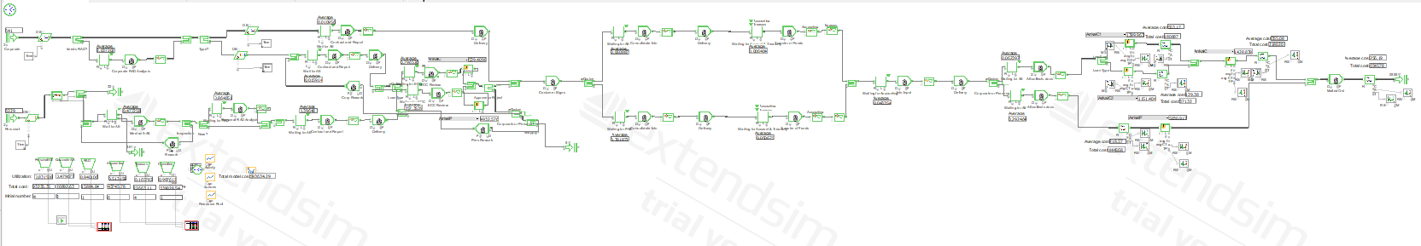

Figure 2. ExtendSim Model of Current Process

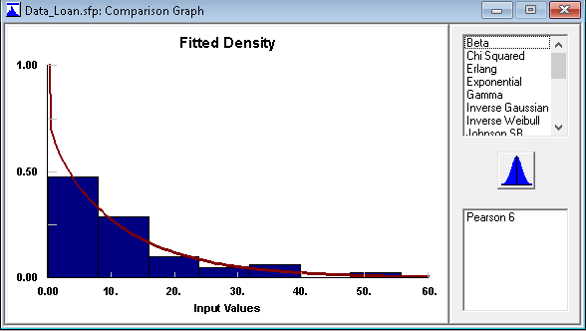

Figure 3. Fitted Density of Personal Loan Application Interarrival Times

# 

Figure 4. Auto::Fit Results for Fit of Distributions for Personal Loan Application Interarrival Times

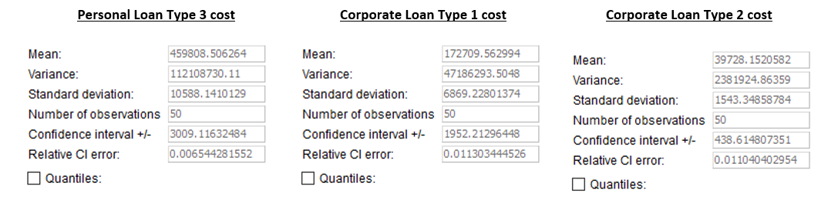Figure 5. Current Process Costs Per Loan Application

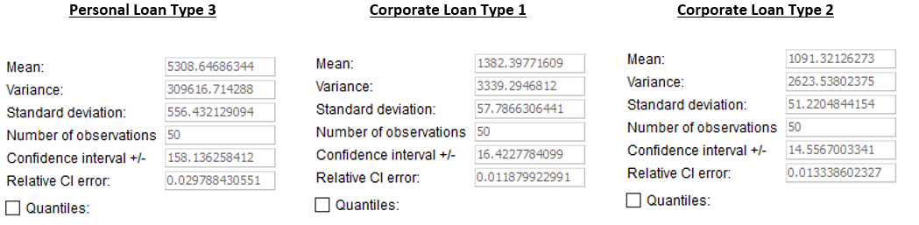

Figure 6. Current Process Cycle Times

# 

# Figure 7. Current Process Throughput Rate

# 

# Figure 8. Resource Pool Statistics

# 

# Figure 9. Utilization rates over 80 days. The **red line** represents the treasury utilization rates, the **light blue line** represents the accounting utilization rates, the **dark green line** represents the ECAC utilization rates.

# 

# 

# Figure 10. Utilization rates over 80 days. The **red line** represents the corporate AE utilization rates, the **light blue line** represents the personal AE utilization rates, the **dark green line** represents the RAD utilization rates.

# 

# 

# Figure 11. Current Process Activity Statistics

# 

# 

# Figure 12. Current Process Queue Statistics

# 

Figure 13a. Factors for Scenario Manager

# 

Figure 13b. Responses for Scenario Manager

# 

# 

Figure 14a. Optimized Model Cycle Times

# 

Figure 14b. Current Model Cycle Times

# 

Figure 15a. Optimized Model Total Cost

# 

Figure 15b. Current Model Total Cost

# 

Figure 16a. Optimized Model Resource Utilization

# 

Figure 16b. Current Model Resource Utilization

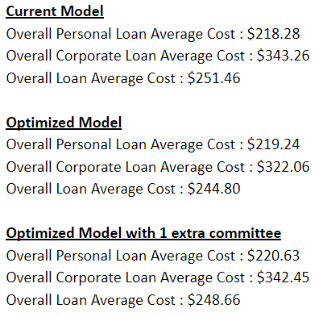

Figure 17. Average Cost Per Loan Application

# 

Figure 18. Cycle Times with Additional Committee

# 

Figure 19. Overall Cost with Additional Committee